**Prokaryotic and Eukaryotic Cells**

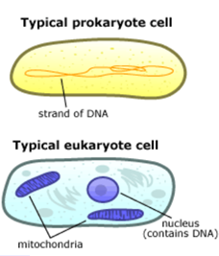Living things have evolved into three large clusters of closely related organisms, called "domains": Archaea, Bacteria, and Eukaryota. Archaea and Bacteria are small, relatively simple single cell organisms that are surrounded by a membrane and a cell wall, with a circular strand of DNA containing their genes. They are called prokaryotes.

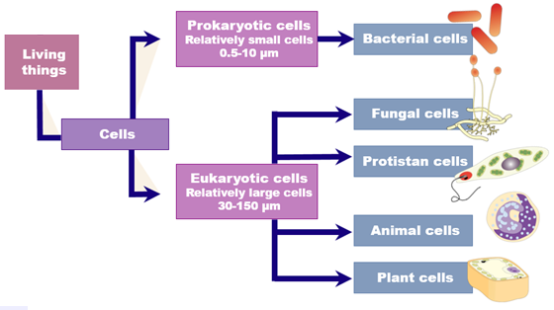Eukaryotic cells are more complex than prokaryotes, and the DNA is linear and packaged within a nucleus. Among other specialised organelles, eukaryotic cells also boast their own personal "power plants", called [mitochondria](https://evolution.berkeley.edu/evolibrary/glossary/glossary_popup.php?word=mitochondrion). These tiny organelles not only use glucose and oxygen to produce ATP, the energy currency of the cell, but they also hold the key to understanding the evolution of the eukaryotic cell.

Due to their common evolutionary past, prokaryotic and eukaryotic cells have many features in common. But how did a humble bacterium make this evolutionary leap from a simple prokaryotic cell to a more complex eukaryotic cell? The answer seems to be symbiosis — in other words, teamwork!

Evidence supports the idea that eukaryotic cells are actually the descendants of separate prokaryotic cells that joined together. In fact, the mitochondrion itself seems to be the "great-great-great-great-great-great-great-great-great granddaughter" of a free-living bacterium that was engulfed by another cell, perhaps as a meal, and ended up staying as a sort of permanent houseguest. The host cell profited from the chemical energy the mitochondrion produced, and the mitochondrion benefited from the protected, nutrient-rich environment surrounding it.

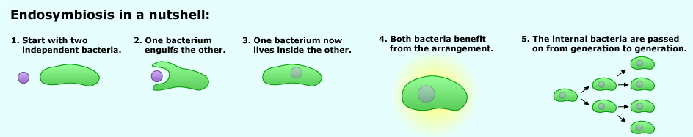

Since prokaryotic cells lack organelles, they do not have a ‘personal power plant’ to produce ATP. Instead they must acquire their energy source by other means. Some prokaryotes engulf their food source. Others photosynthesize (like plants) using chlorophyll contained in vesicles within the cell. If they don’t have access to sunlight, prokaryotes may have to rely on chemicals sourced from hydrothermal vents. Enzymes within the membrane of a prokaryotes then use the chemical source obtained to generate ATP for the cell.

**Prokaryotic and Eukaryotic Cells**

Living things have evolved into three large clusters of closely related organisms, called "domains": Archaea, Bacteria, and Eukaryota. Archaea and Bacteria are small, relatively simple single cell organisms that are surrounded by a membrane and a cell wall, with a circular strand of DNA containing their genes. They are called prokaryotes.

Eukaryotic cells are more complex than prokaryotes, and the DNA is linear and packaged within a nucleus. Among other specialised organelles, eukaryotic cells also boast their own personal "power plants", called [mitochondria](https://evolution.berkeley.edu/evolibrary/glossary/glossary_popup.php?word=mitochondrion). These tiny organelles not only use glucose and oxygen to produce ATP, the energy currency of the cell, but they also hold the key to understanding the evolution of the eukaryotic cell.

Due to their common evolutionary past, prokaryotic and eukaryotic cells have many features in common. But how did a humble bacterium make this evolutionary leap from a simple prokaryotic cell to a more complex eukaryotic cell? The answer seems to be symbiosis — in other words, teamwork!

Evidence supports the idea that eukaryotic cells are actually the descendants of separate prokaryotic cells that joined together. In fact, the mitochondrion itself seems to be the "great-great-great-great-great-great-great-great-great granddaughter" of a free-living bacterium that was engulfed by another cell, perhaps as a meal, and ended up staying as a sort of permanent houseguest. The host cell profited from the chemical energy the mitochondrion produced, and the mitochondrion benefited from the protected, nutrient-rich environment surrounding it.



Since prokaryotic cells lack organelles, they do not have a ‘personal power plant’ to produce ATP. Instead they must acquire their energy source by other means. Some prokaryotes engulf their food source. Others photosynthesize (like plants) using chlorophyll contained in vesicles within the cell. If they don’t have access to sunlight, prokaryotes may have to rely on chemicals sourced from hydrothermal vents. Enzymes within the membrane of a prokaryotes then use the chemical source obtained to generate ATP for the cell.